1. Introduction
• Overview of the problem: MediaStream Inc. needs to prioritize latency-sensitive video control traffic over bulk data transfers across a single shared WAN link.
• Importance of Policy-Based Routing (PBR) and application-aware routing in SD-WAN.
• In a real network, routers perform PBR by matching packets (ports, protocols, DSCP) and sending them through selected interfaces.
• NS-3 routing is static by default, so we must extend or override routing to implement application-aware behavior.

Objectives
• Simulate distinct traffic flows.
• Implement PBR in NS-3 to classify video vs. data.
• Measure performance using FlowMonitor.
• Design a basic SD-WAN-style dynamic controller.

2. Traffic Classification Logic

2.1 Flow_Video – RTP-like Traffic

Small, constant packets and delay-sensitive.

Why these parameters matter:
• Small packets reduce serialization delay.
• High sending frequency mimics real-time control.
• Port 5004 is a standard RTP/RTCP port.

OnOffHelper videoApp("ns3::UdpSocketFactory", Address(InetSocketAddress(cloudIP, 5004)));
videoApp.SetAttribute("PacketSize", UintegerValue(128));
videoApp.SetAttribute("DataRate", StringValue("512kbps"));
videoApp.SetAttribute("OnTime", StringValue("ns3::ConstantRandomVariable[Constant=1]"));
videoApp.SetAttribute("OffTime", StringValue("ns3::ConstantRandomVariable[Constant=0]"));

2.2 Flow_Data – FTP-like Traffic

Large packets, bulk transfer, throughput-focused.

– Reasoning:
BulkSend automatically pushes data as fast as TCP allows, creating congestion and longer queues.

BulkSendHelper dataApp("ns3::TcpSocketFactory", Address(InetSocketAddress(cloudIP, 21)));
dataApp.SetAttribute("MaxBytes", UintegerValue(0));

3. Implementing PBR in NS-3

Clear explanation NS-3 default routing

NS-3 normally uses:
• GlobalRouting (shortest path)
• StaticRouting (manual)
• Ipv4ListRouting (priority list)

But none support PBR natively, so we must customize.

3.1 Packet Classification

Match traffic using ports, protocol numbers, or DSCP marks.

3.2 Architecture

Two WAN interfaces:
• Interface 1 → Low latency
• Interface 2 → High bandwidth

We intercept packet processing and choose the interface.

3.3 Pseudocode

if (packet.GetDscp() == DSCP_VIDEO || dstPort == 5004) {
routeViaInterface(if1);
} else if (dstPort == 21) {
routeViaInterface(if2);
}

– How to override NS-3 behavior:

Options:
1. Create a custom routing protocol class (inherits Ipv4RoutingProtocol)
2. Patch Ipv4L3Protocol::Send() using a Tx trace callback
3. Use FlowClassifier + NetDeviceQueue selection
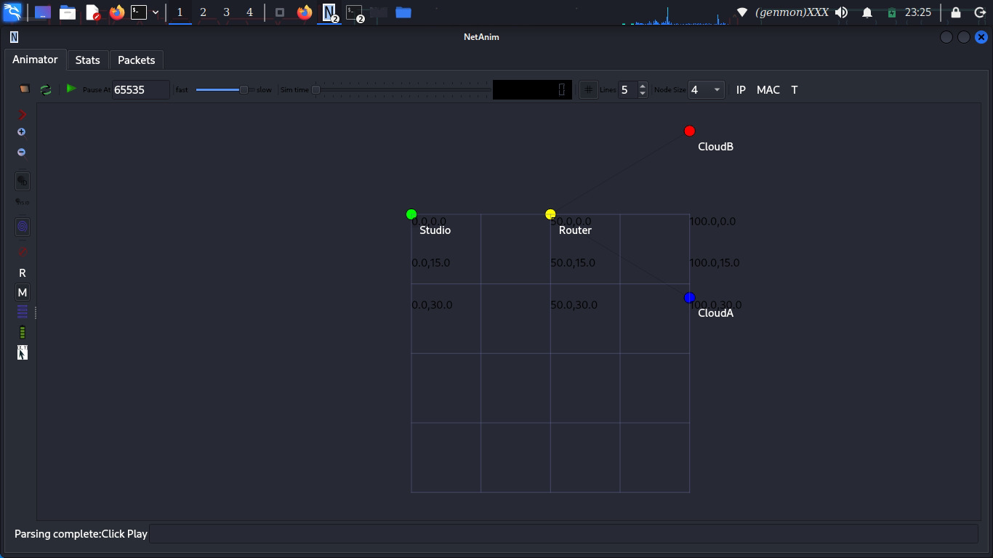

4. Path Characterization

4.1 Measuring Performance

Use FlowMonitor to get delay, jitter, loss, throughput.

double delay = flowStats[flowId].delaySum.GetSeconds() / flowStats[flowId].rxPackets;
double throughput = (flowStats[flowId].rxBytes * 8.0) / duration;

Recommended extra metrics:
• Jitter: variation of delay (critical for video)
• Packet loss: congestion indication
• Queue occupation: helps identify bottleneck link

4.2 Making Metrics Available

Store collected values:

– Example struct:

struct LinkMetrics {
double delay;
double jitter;
double loss;
double throughput;
};

These can be shared with the PBR controller.

5. Dynamic Policy Engine

5.1 Logic

Periodically read network metrics and adapt routing.

if (videoDelay > 30ms) {
updateRouteTable("Flow_Video", secondaryLink);
}

✔️ More triggers:
• If link utilization > 70% → reroute FTP
• If packet loss > 3% → reroute video

5.2 C++ Controller Structure

class PbrController {
public:
void MonitorLinks();
void ApplyPolicy();
void UpdateRoutingTable();
private:
std::map<std::string, double> linkLatencies;
Ipv4RoutingTable *routingTable;
};

– Scheduling

Simulator::Schedule(Seconds(1.0),
&PbrController::MonitorLinks, controller);

6. Validation and Trade-offs

– Simulation results you must verify
• Video packets should always use interface 1 (low latency)
• Data packets should prefer interface 2 (high bandwidth)
• If congestion appears, the controller must react
• End-to-end delay for video must remain < 30 ms

6.2 Trade-offs Table

Aspect | Real Router | NS-3 Simulation
PBR implementation | Hardware-accelerated | CPU-based, slower
Scaling | Very large | Limited
Real-time behavior | True real-time | Emulated time
Reliability | Production-ready | Research/testing

NS-3 is ideal for algorithm testing but cannot model exact router ASIC behavior.

7. Conclusion;

This project demonstrates how NS-3 can be extended beyond basic routing to simulate SD-WAN-like intelligent forwarding.

8. References
recommended NS-3 modules for further work:
• TrafficControlModel
• QueueDisc (RED, FQ-CoDel)
• PointToPointNetDevice

